Excel Automation Report
Our stakeholder has given access to his database, wanting weekly report on some specific business questions and also want scheduled emails to a certain segment of customers.
- Stakeholder is non-technical and would not want be overwhelmed with a report filled with charts
- We would be answering his business questions directly on the spreadsheet and automate the process in a way we just have to refresh the report and send in a new spreadsheet weekly
- Weekly scheduled emails would be going out to our top customers
- Emails would also be going out to our customers whose revenue declined in the new week
Tools stack
- PostgreSQL
- Microsoft Excel
- Microsoft Power Automate
Database
I created database on Postgre and generated values for each of the tables, since I don’t have one already.
Dimension Tables
- Dim_customer
- Dim_date
- Dim_product
- Dim_sales_rep
Fact Tables
- Orders
- Order_items
Views
- vw_weekly_customer_sales; Records -- Weekly revenue per customer, Order count per customer
- vw_weekly_sales_rep; Records -- Weekly revenue per rep, Rank for each week, Orders handled, Region / state mapping
- vw_weekly_product; Records -- weekly product revenue, units sold, and demand rank.
- vw_weekly_customer_wow; Records—Customer revenue behavior based on previous and current week
- vw_weekly_customer_trend; Pulls data from vw_weekly_customer_wow and classifies the revenue trend (“No prior data”, “Declined”, “Increased”)

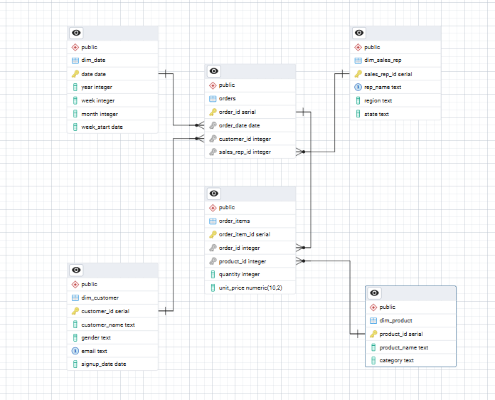

Power BI Reporting
Before moving data to Power Bi I created a central table that maps all tables to their corresponding column. This is to avoid modeling issues in power bi. i.e we would be having only values that match each and every table no nulls, This is relative to the analysis I want to perform some analysis would require the whole data and this style would not be recommended
New Derived View; public vw_sales_analysis
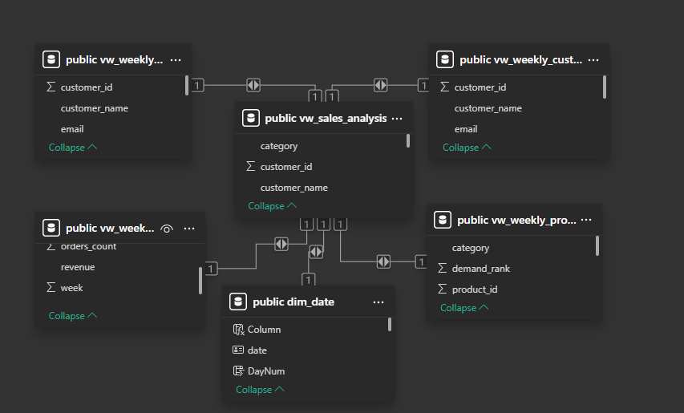
My main objective on power bi is to answer stakeholder’s question directly, So I went into assigning synonyms to columns, creating measures for specific questions and hiding columns that would make my Q and A model ambiguous. N/B: I used a single Q&A chart and implemented all my settings inside it (Felt like a backend guy lowkey lol)
Having done this I went straight into testing the model and verifying with a table chart , Below are stakeholders questions.
Who are our top 5 customer?

Who is our top sales rep?

Which sales rep has the lowest performance?

Who are the customers with declining revenue?

Five products with low demand?

Five products with high demand?

State with highest revenue?

State with lowest revenue?

Let’s go ahead to paste this question in our model and verify
- Who are our top 5 customer?
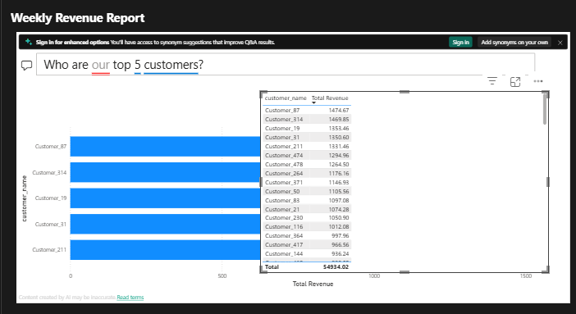

- Who is our top sales rep?
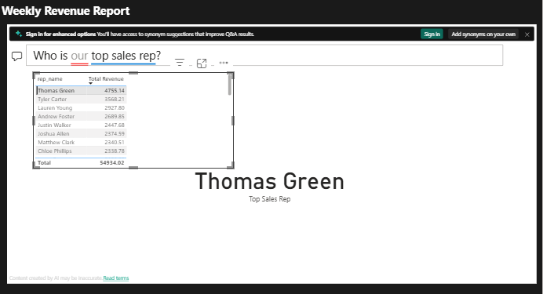
- Which sales rep has the lowest performance?
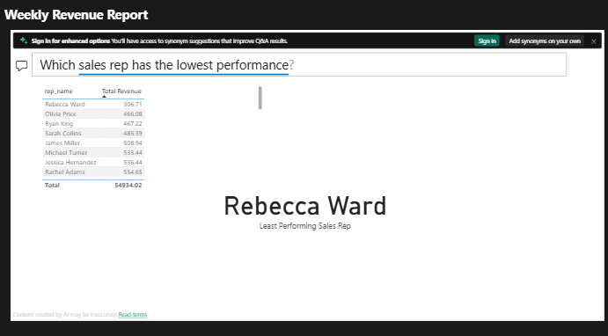

- Who are the customers with declining revenue?
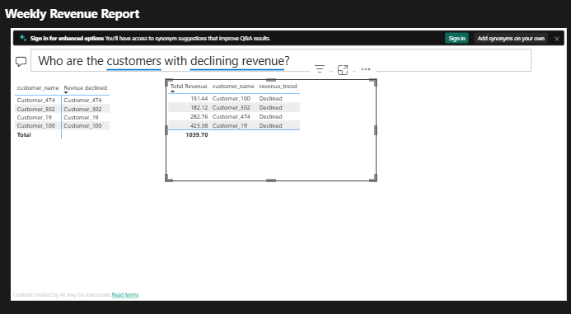

- Five products with lowest demand?
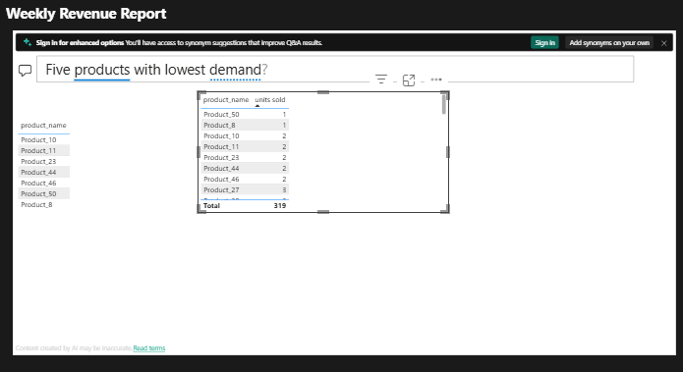

- Five products with high demand?
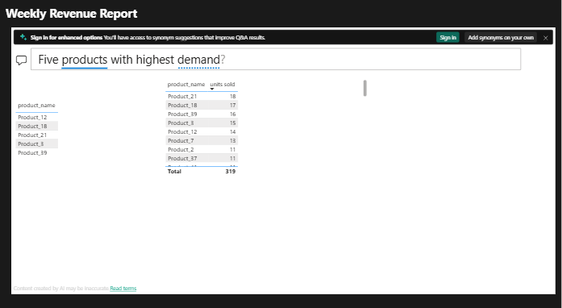

- State with highest revenue?
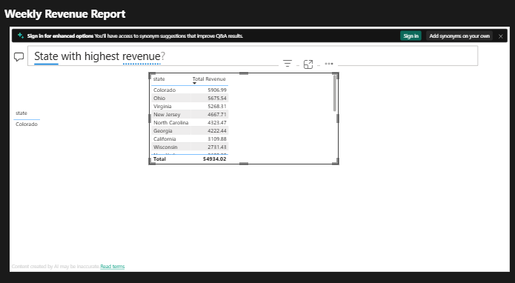

- State with lowest revenue?
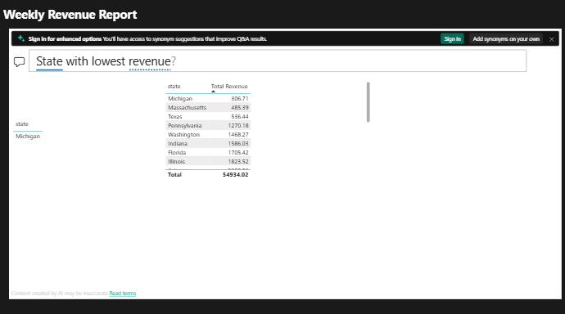

I went ahead to play with other charts and kpis I felt will be valuable to a weekly revenue report which I will also attach to this documentation.

Scheduling and Automation
The idea was to trigger weekly schedules to certain segments of customers, However I needed up to date data which would be refreshing every week (i.e weekly data to pull up to current date).

Meanwhile my database had only data for 2024, I had to update it with auto generated data for the sake of this project. I successfully updated my date table inside PostgreSQL but the orders table was a big headache, it kept returning orders from just one customer and one sales rep. I had to improvise and switch to python.

I finally created a python script that updated my orders and order item table and I set the script to keep updating new data to this tables using the foreign keys from my dimension tables and also making sure the impact was random, different customers, different sales reps and at different times every day moving forward; This way my database stays up to current date at anytime as long as the script is hosted in a scheduler that triggers this update.

Scheduling Emails to Top Customers and Customers with Declining Revenue
It gets more interesting, We are creating an intelligence system where python goes into our database to get this segment of customers and automatically send emails to them according to stakeholder preference.

I created an audit log table to start with in my database; this table logs all activity for these scheduled emails letting us know which emails failed to send and which of them went through. This log also helps avoid duplicate mailing.

After creating my log, I realized for smooth scheduling, the database need to move to the cloud. Which takes us to data migration. I would be migrating the current data from my local host to a cloud database through python

Data Migration
Current look of my on prem data base with validations for constraints, totals and foreign keys check.

Migration Plan
- We are migrating RetailDB from current on premises to a cloud database. stakeholder finds it difficult to effect scheduled emailing when the physical server loses connection. The solution is cloud automation, however cloud server cannot read on prem database even when we use a connector.

Dear Data bender, we require that you successfuly migrate our database which comprises 7 tables with at least 190,000 rows in total. Constraints and dependencies are present, we don't expect to lose any of this.

Tables:7
Foreign Tables:0

dim_customer;
Columns -- 5. customer_id, customer_name, gender, email, signupdate
Rows -- 500
Constraints: email_key, gender_check, primary_key

dim_date;
Columns -- 5. date, year, week, month, week_start
Rows -- 788
Constraints -- primary_key

dim_product;
Columns -- 3. product_id product_name, category
Rows -- 50
Constraints -- primary_key

dim_sales_rep;
Columns 4. sales_rep_id, rep_name, region,state
Rows -- 40
Constraints -- primary_key, rep_name_key

email_log;
Columns -- 9. log_id, customer_name, cutomer_email, email_type, subject, sent_at, year, week, status
Rows -- 0
Constraints -- primary_key

order_items;
Columns -- 5. order_item_id, order_id, product_id, quatity, unit_price
Rows -- 62835
Constraints -- order_id_fkey, primary_key, product_id_fkey
Sum of unit_price -- 15844783.98
Sum of quantity -- 345914

orders;
Columns -- 4. order_id, order_date, customer_id, sales_rep_id
Rows -- 21071
Constraints -- order_date_fkey, customer_id_fkey, primary_key, sales_rep_id_fkey

Migration Process
Step 1. I created a back up dump file for the entire database just incase anything fails (e.g migration engineer mistakenly drops an entire table or mess with dependencies on the source DB)

"C:\Program Files\PostgreSQL\16\bin\pg_dump.exe" -h localhost -U postgres -F c -b -v -f "C:\Users\ty\RetailDB_pre_migration.dump" RetailDB

Step 2. Migrate only schema data and validate

Migration Script:
- set PGPASSFILE=C:\Users\ty\AppData\postgresql\pass.conf
- "C:\Program Files\PostgreSQL\16\bin\pg_dump.exe" -h localhost -U postgres -s RetailDB | "C:\Program Files\PostgreSQL\16\bin\psql.exe" "host=ep-withered-meadow-agm7360c-pooler.c-2.eu-central-1.aws.neon.tech user=neondb_owner dbname=retaildb_cloud sslmode=require"

Validation Script:
"C:\Program Files\PostgreSQL\16\bin\psql.exe" "host=ep-withered-meadow-agm7360c-pooler.c-2.eu-central-1.aws.neon.tech user=neondb_owner dbname=retaildb_cloud sslmode=require" -c "SELECT table_name FROM information_schema.tables WHERE table_schema='public';"

After migration of schema and tables, I validated the process and confirmed the tables were complete as well as columns in the tables and constraints.

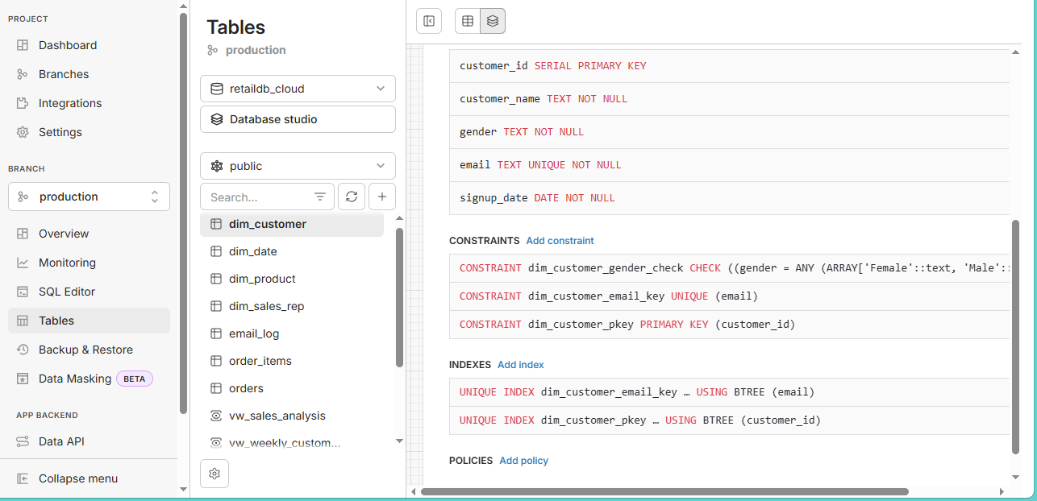

Step 3. Insert data Table by Table
Dim_date:

Migration Script:
- set PGPASSFILE=C:\Users\ty\AppData\postgresql\pass.conf
- "C:\Program Files\PostgreSQL\16\bin\pg_dump.exe" -h localhost -U postgres --data-only --table=dim_date RetailDB | "C:\Program Files\PostgreSQL\16\bin\psql.exe" "host=ep-withered-meadow-agm7360c-pooler.c-2.eu-central-1.aws.neon.tech user=neondb_owner dbname=retaildb_cloud sslmode=require"

Validation Script:
"C:\Program Files\PostgreSQL\16\bin\psql.exe" "host=ep-withered-meadow-agm7360c-pooler.c-2.eu-central-1.aws.neon.tech user=neondb_owner dbname=retaildb_cloud sslmode=require" -c "SELECT COUNT(*) FROM dim_date;"

Migration was successful after validating for row counts to match on prem row count
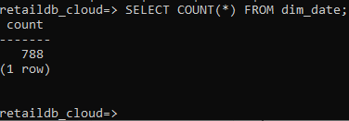

Dim_customer: I repeated the same steps with the same command script changing only the table name. Migration was as well successful after running validation check
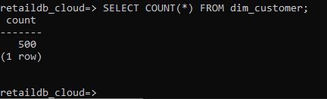

Dim_product: Migration was successful, after validation row counts match
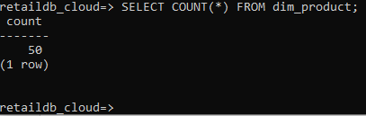

Dim_sales_rep: Migration was successful, after validation row counts match
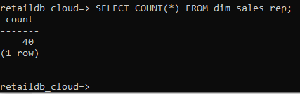

Orders: Migration was successful, Row counts match after validation
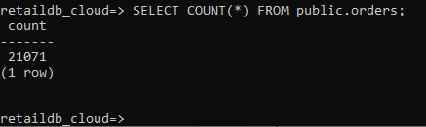

Order_items: Migration was successful, Row counts and sums match after validation.
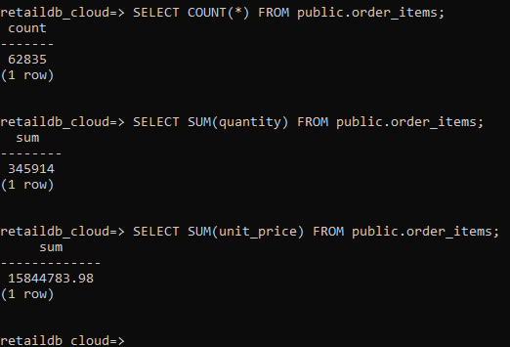

After successful migration to the cloud database we go ahead to set our scheduling script up for automations

Email Scheduling
Top Customers: I segmented customers who have brought revenue over $20,000 in the last 7 days using a python script, This script gets the said customers and their email sending them a voucher. The script is scheduled to do continue doing this as long as it is hosted in an automated scheduler.

I ran the first batch of email and it was successful. I would be hosting the script on github actions to do this weekly.

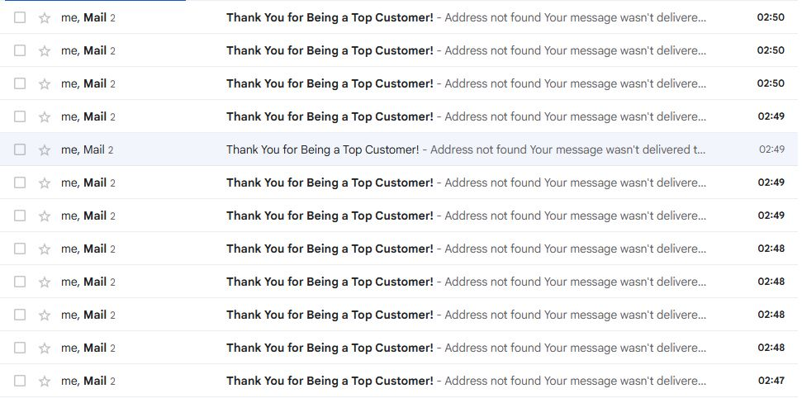
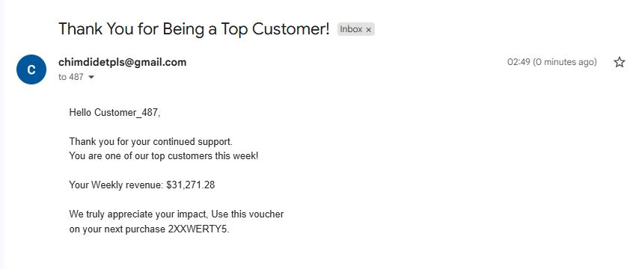

Customers with declining revenue
I did the same with customers with declining revenue, using a view I had earlier created to track customers current and previous revenue.

I went ahead to test run the script and our first batch of emails also went through
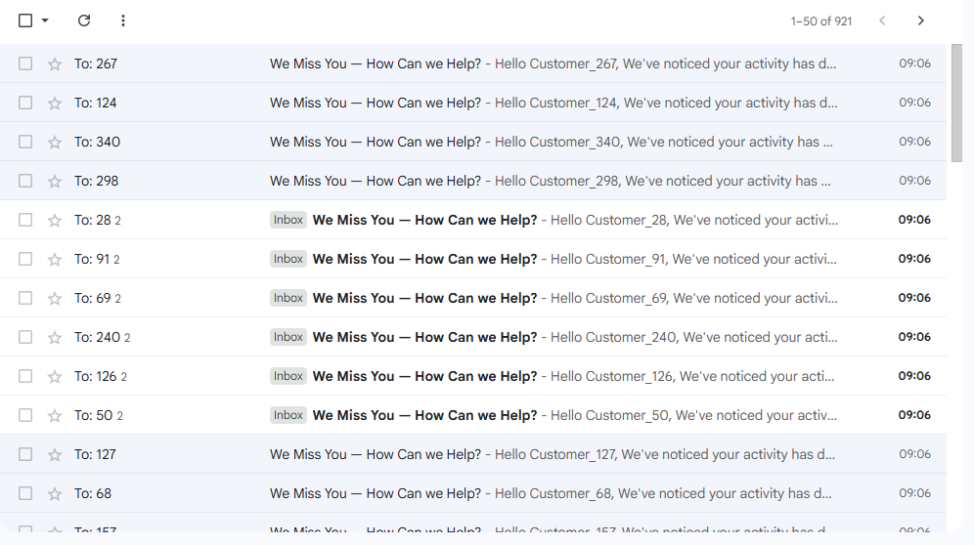
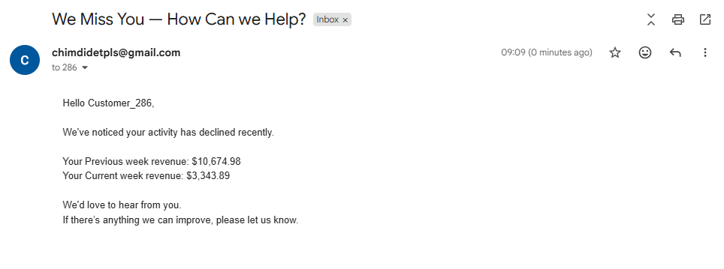
Moving forward we schedule our scripts for continuous automation in the cloud

Github Actions Scheduling

